**KUBERNETES INSTALLATION**

\*Firstly, you need to create aws **Iam user account**

* Create a iam user account with the administrator policy
* Next step is to login with the created iam-user.
* Create a role for the eks-custer ( Eks service )

Go to iam service >> click on the roles >> create a role >> click on aws service and use case as ec2 instance >> next >>

Add permissions as AmazonEKSCluster policy >> enter name of the role >> create the role .

* Create a role for the eks-worker-node ( Eks worker node)
* Go to iam service >> click on the roles >> create a role >> click on aws service and use case as ec2 instance >> next >>
* Add permissions as AmazonEKSCluster policy, AmazonEksWorkerNode Policy, AmazaonEc2ContainerRegistryRead policy, AmazonEks\_CNI\_Policy >> enter name of the role >> create the role .

\*Creation of the **Ec2 instance**

* Create an instance with instance type t2.medium ; Ubuntu Ami ; Security group with http
* Now connect the instance with gitbash terminal

sudo apt-get update -y

1. curl "https://awscli.amazonaws.com/awscli-exe-linux-x86\_64.zip" -o "awscliv2.zip"

for the reference use below link for cli installation

( <https://docs.aws.amazon.com/cli/latest/userguide/getting-started-install.html> )

1. sudo apt-get update -y
2. sudo apt install unzip
3. unzip awscliv2.zip
4. sudo ./aws/install
5. curl -o aws-iam-authenticator <https://s3.us-west-2.amazonaws.com/amazon-eks/1.21.2/2021-07-05/bin/linux/amd64/aws-iam-authenticator>

for the reference use below link for aws iam installation

( <https://docs.aws.amazon.com/eks/latest/userguide/install-aws-iam-authenticator.html>)

1. chmod +x ./aws-iam-authenticator
2. aws --version
3. aws configure

( enter Iam user access key ,seceret key, default region )

1. curl -o kubectl <https://s3.us-west-2.amazonaws.com/amazon-eks/1.22.6/2022-03-09/bin/linux/amd64/kubectl>

for the reference use below link for Kubernetes installation

( <https://docs.aws.amazon.com/eks/latest/userguide/install-kubectl.html>)

1. chmod +x ./kubectl
2. mkdir -p $HOME/bin && cp ./kubectl $HOME/bin/kubectl && export PATH=$PATH:$HOME/bin
3. aws eks --region ap-southeast-1 update-kubeconfig --name eks-cluster

region ap-southeast-1 ( region ) ; name eks-cluster ( give the name of the eks cluster)

\*\* ( before the 12 step need to create the Eks cluster below are the steps for the cluster creation ) \*\*

Aws account Search [**Amazon Elastic Kubernetes Service**](https://ap-southeast-1.console.aws.amazon.com/eks/home?region=ap-southeast-1#/home)

1. Click Add Cluster
2. Name of the cluster
3. Select the Role([AmazonEKSClusterPolicy](https://us-east-1.console.aws.amazon.com/iam/home" \l "/policies/arn:aws:iam::aws:policy/AmazonEKSClusterPolicy" \t "_blank))
4. Create cluster

* After the creation of the cluster need to create the node

1. GO to compute in eks cluster

1. Click add node group

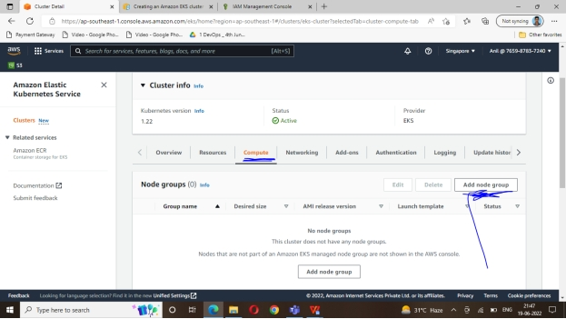

1. Node name Eks-node-roles(worker-node)

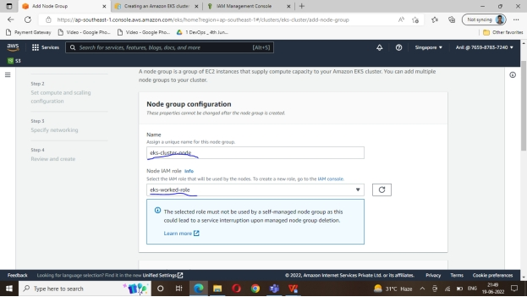

1. Select the Ami type Instance type

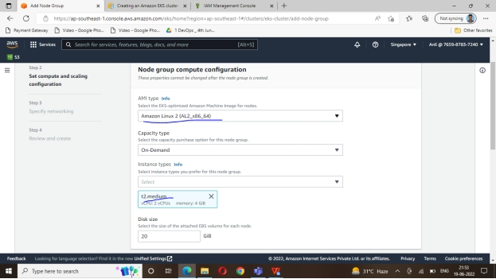

1. Chooses you nodes for auto scaling configuration( 1 or more)

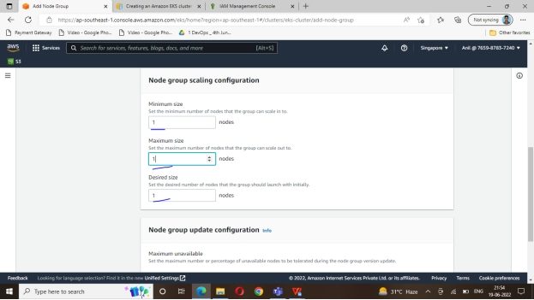

1. add the default Subnet

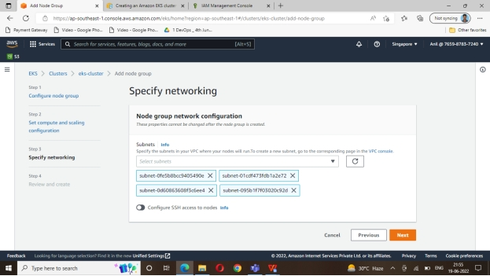

\*Next go to the ec2 instance and connect the master-eks instance

\*You can see the node also created

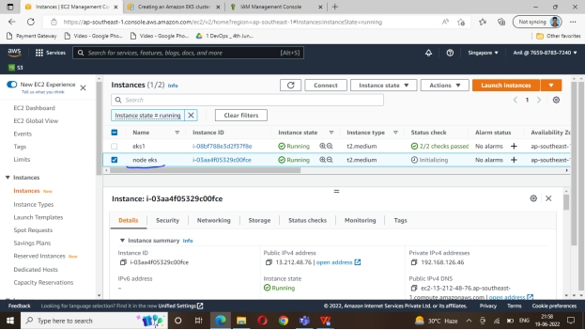

\*Open eks-master terminal

Execute the Below commands

$ kubectl get all

$ kubect get nodes ( we can see the all the nodes and clusters)

Some commands in Kubernetes

1. It will display all the cluster details

Kubectl get all

1. It will display all nodes connected to the cluster  
    kubectl get nodes
2. It will display the all pods

Kubectl get pods

1. To see more info about the pods like their ip and slave where they are running

kubectl get pods -o wide

1. To create the pod

Kubectl apply -f webserver (yamlfile name )

1. To delete the pod

kubectl delete pods webserver ( Name of the yamlfile )

1. To check if the deployment is running

kubectl get deployment

1. To see the namespace

Kubectl get namespace

1. To see list of pods in a namespace

kubectl get pods -n test ( namespace name )

1. To delete a namespace

kubectl delete namespace test ( namespace name )

|  |  |  |
| --- | --- | --- |
|  |  |  |
|  |  |
|  |  |
|  |  |
|  |  |
|  |  |
|  |  |
|  |  |
|  |  |
|  |  |
|  |  |
|  |  |
|  |  |
|  |  |
|  |  |
|  |  |
|  |  |
|  |  |
|  |  |
|  |  |
|  |  |
|  |  |
|  |  |
|  |  |
|  |  |
|  |  |
|  |  |
|  |  |
|  |  |
|  |  |
|  |  |
|  |  |
|  |  |
|  |  |
|  |  |
|  |  |
|  |  |
|  |  |
|  |  |
|  |  |
|  |  |
|  |  |
|  |  |